INTERNET PROTOCOLS

The **Internet Protocol Suite** (commonly known as **TCP/IP**) is the set of communications protocols used for the Internet and other similar networks. It is named from two of the most important protocols in it: the **Transmission Control Protocol (TCP)** and the **Internet Protocol (IP)**, which were the first two networking protocols defined in this standard. Today's IP networking represents a synthesis of several developments that began to evolve in the 1960s and 1970s, namely the Internet and LANs (Local Area Networks), which emerged in the mid- to late-1980s, together with the advent of the World Wide Web in the early 1990s.

The Internet Protocol Suite, like many protocol suites, may be viewed as a set of layers. Each layer solves a set of problems involving the transmission of data, and provides a well-defined service to the upper layer protocols based on using services from some lower layers. Upper layers are logically closer to the user and deal with more abstract data, relying on lower layer protocols to translate data into forms that can eventually be physically transmitted.

The TCP/IP model consists of four layers. From lowest to highest, these are the Link Layer, the Internet Layer, the Transport Layer, and the Application Layer.

**History**

The Internet Protocol Suite resulted from work done by **Defense Advanced Research Projects Agency (DARPA)** in the early 1970s. After building the pioneering ARPANET in 1969, DARPA started work on a number of other data transmission technologies. In 1972, Robert E. Kahn was hired at the DARPA Information Processing Technology Office, where he worked on both satellite packet networks and ground-based radio packet networks, and recognized the value of being able to communicate across them. In the spring of 1973, Vinton Cerf, the developer of the existing ARPANET Network **Control Program (NCP)** protocol, joined Kahn to work on open-architecture interconnection models with the goal of designing the next protocol generation for the ARPANET.

With the role of the network reduced to the bare minimum, it became possible to join almost any networks together, no matter what their characteristics were, thereby solving Kahn's initial problem. One popular saying has it that TCP/IP, the eventual product of Cerf and Kahn's work, will run over "two tin cans and a string." There is even an implementation designed to run using homing pigeons, IP over Avian Carriers.

A computer called a *router* (a name changed from *gateway* to avoid confusion with other types of *gateway*s) is provided with an interface to each network, and forwards packets back and forth between them.

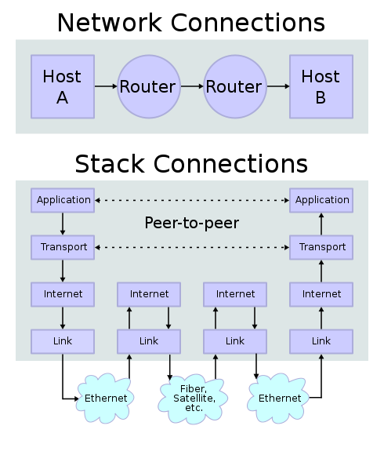The idea was worked out in more detailed form by Cerf's networking research group at Stanford in the 1973–74 period, resulting in the first TCP specification (The early networking work at Xerox PARC, which produced the PARC Universal Packet protocol suite, much of which existed around the same period of time, was also a significant technical influence; people moved between the two.)

In 1975, a two-network TCP/IP communications test was performed between Stanford and *University College London (UCL).* In November, 1977, a three-network TCP/IP test was conducted between sites in the US, UK, and Norway. Several other TCP/IP prototypes were developed at multiple research centers between 1978 and 1983. The migration of the ARPANET to TCP/IP was officially completed on January 1, 1983 when the new protocols were permanently activated.

**Figure 1 : TCP/IP stack operating on two hosts connected via two routers and the corresponding layers used at each hop**

In March 1982, the US Department of Defense declared TCP/IP as the standard for all military computer networking. In 1985, the Internet Architecture Board held a three day workshop on TCP/IP for the computer industry, attended by 250 vendor representatives, promoting the protocol and leading to its increasing commercial use.

**Layers**

The TCP/IP suite uses encapsulation to provide abstraction of protocols and services. Such encapsulation usually is aligned with the division of the protocol suite into layers of general functionality. In general, an application (the highest level of the model) uses a set of protocols to send its data down the layers, being further encapsulated at each level.

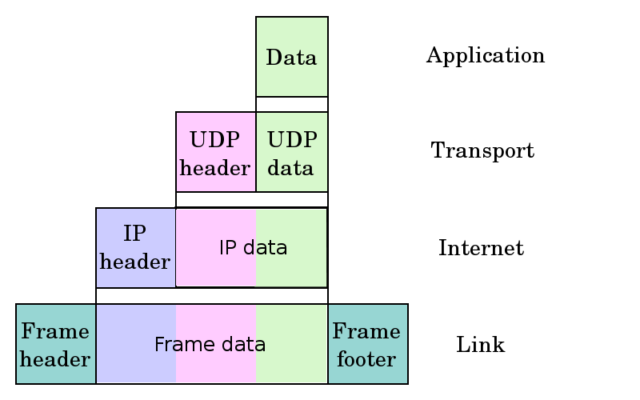This may be illustrated by an example network scenario, in which two Internet host computers communicate across local network boundaries constituted by their internetworking gateways (routers).

The functional groups of protocols and methods are the **Application Layer**, the **Transport Layer**, the **Internet Layer**, and the **Link Layer**. It should be noted that this model was not intended to be a rigid reference model into which new protocols have to fit in order to be accepted as a standard.

**Figure 2 : Encapsulation of application data descending through the protocol stack.**

**Application Layer**

**Application Layer** is a term used in categorizing protocols and methods in architectural models of computer networking. Both the OSI model and the Internet Protocol Suite (TCP/IP) contain an application layer.

In TCP/IP, the Application Layer contains all protocols and methods that fall into the realm of process-to-process communications via an Internet Protocol (IP) network using the Transport Layer protocols to establish underlying host-to-host connections.

In the OSI model, the definition of its Application Layer is narrower in scope, distinguishing explicitly additional functionality above the Transport Layer at two additional levels: Session Layer and Presentation Layer. OSI specifies strict modular separation of functionality at these layers and provides protocol implementations for each layer.

The common application layer services provide semantic conversion between associated application processes. *Note:* Examples of common application services of general interest include the virtual file, virtual terminal, and job transfer and manipulation protocols.

* **Dynamic Host Configuration Protocol** (**DHCP**) is a network application protocol used by devices (*DHCP clients*) to obtain configuration information for operation in an Internet Protocol network. This protocol reduces system administration workload, allowing devices to be added to the network with little or no manual intervention.
* **Domain Name System** (**DNS**) is a hierarchical naming system for computers, services, or any resource participating in the Internet. It associates various information with domain names assigned to such participants. Most importantly, it translates domain names meaningful to humans into the numerical (binary) identifiers associated with networking equipment for the purpose of locating and addressing these devices world-wide.
* **File Transfer Protocol** (**FTP**) is a used to exchange and manipulate files over a computer network, such as the . An FTP client may connect to an to manipulate files on that server.
* **GPRS Tunneling Protocol** (**GTP**) is a group of IP-based communications protocols used to carry General Packet Radio Service (GPRS) within GSM and UMTS networks.
* **Hypertext Transfer Protocol** (**HTTP**) is an application-level protocol for distributed, collaborative, hypermedia information systems. Its use for retrieving inter-linked resources led to the establishment of the World Wide Web.
* **Internet Message Access Protocol** (**IMAP)** is one of the two most prevalent Internet standard protocols for e-mail retrieval, the other being POP3. Virtually all modern e-mail clients and servers support both protocols as a means of transferring e-mail messages from a server, such as those used by Gmail, to a client, such as Mozilla Thunderbird, Apple Mail and Microsoft Outlook. Once configured, the client's use of such protocols remains transparent to the user.
* **Internet Relay Chat** (**IRC**) is a form of real-time Internet text messaging (chat) or synchronous conferencing. It is mainly designed for group communication in discussion forums, called *channels*, but also allows one-to-one communication via private message, as well as chat and data transfers via Direct Client-to-Client.
* **Network Time Protocol** (**NTP**) is a protocol for synchronizing the clocks of computer systems over packet-switched, variable-latency data networks. NTP uses UDP on port 123 as its transport layer. It is designed particularly to resist the effects of variable latency by using a jitter buffer. NTP also refers to a reference software implementation that is distributed by the NTP Public Services Project.
* **Post Office Protocol version 3** (**POP3**) is an application-layer Internet standard protocol used by local e-mail clients to retrieve e-mail from a remote server over a TCP/IP connection. POP3 and IMAP4 (Internet Message Access Protocol) are the two most prevalent Internet standard protocols for e-mail retrieval. Virtually all modern e-mail clients and servers support both.
* **Real-time Transport Protocol** (**RTP**) defines a standardized packet format for delivering audio and video over the Internet. It was developed by the Audio-Video Transport Working Group of the IETF and first published in 1996 as RFC 1889, and superseded by RFC 3550 in 2003.
* **Simple Mail Transfer Protocol** (**SMTP**) is an Internet standard for electronic mail (e-mail) transmission across Internet Protocol (IP) networks. SMTP was first defined in RFC 821 (STD 10), and last updated by RFC 5321 (2008) which describes extended SMTP (ESMTP), the protocol in widespread use today.
* **Telnet** (**Tel**ecommunication **Net**work) is a network protocol used on the Internet or local area networks. It was developed in 1969 beginning with RFC 15 and standardized as IETF STD 8, one of the first Internet standards. Typically, Telnet provides access to a command-line interface on a remote machine.

**Transport Layer**

In computer networking, the **Transport Layer** is a group of methods and protocols within a layered architecture of network components within which it is responsible for encapsulating application data blocks into data units (datagrams, segments) suitable for transfer to the network infrastructure for transmission to the destination host, or managing the reverse transaction by abstracting network datagrams and delivering their payload to an application. Thus the protocols of the Transport Layer establish a direct, virtual host-to-host communications transport medium for applications and therefore also referred to as *transport protocols*.

Transport layers are contained in both the TCP/IP model, which is the foundation of the Internet, and the Open Systems Interconnection (OSI) model of general networking. The definitions of the Transport Layer are slightly different in these two models. This article primarily refers to the TCP/IP model.

The most well-known transport protocol is the Transmission Control Protocol (TCP). It lent its name to the title of the entire Internet Protocol Suite, *TCP/IP*. It is used for connection-oriented transmissions, whereas the connectionless User Datagram Protocol (UDP) is used for simpler messaging transmissions. TCP is the more complex protocol, due to its stateful design incorporating *reliable* transmission. Other prominent protocols in this group are the Datagram Congestion Control Protocol (DCCP) and the Stream Control Transmission Protocol (SCTP).

* **Transmission Control Protocol** (**TCP**) is one of the core protocols of the Internet Protocol Suite. TCP was one of the two original components, with Internet Protocol (IP), of the suite, so that the entire suite is commonly referred to as *TCP/IP*. Whereas IP handles lower-level transmissions from computer to computer as a message makes its way across the Internet, TCP operates at a higher level, concerned only with the two end systems.
* **User Datagram Protocol** (**UDP**) is one of the core members of the Internet Protocol Suite, the set of network protocols used for the Internet. With UDP, computer applications can send messages, in this case referred to as *datagrams*, to other hosts on an Internet Protocol (IP) network without requiring prior communications to set up special transmission channels or data paths. UDP is sometimes called the **Universal Datagram Protocol**.
* **Stream Control Transmission Protocol (SCTP)** is a Transport Layer protocol, serving in a similar role as the popular protocols Transmission Control Protocol (TCP) and User Datagram Protocol (UDP). Indeed, it provides some of the same service features of both, ensuring reliable, in-sequence transport of messages with congestion control.

**Internet Layer**

The **Internet Layer** is a group of internetworking methods in the TCP/IP protocol suite which is the foundation of the Internet. It is the group of methods, protocols, and specifications which are used to transport datagrams (packets) from the originating host across network boundaries, if necessary, to the destination host specified by a network address (IP address) which is defined for this purpose by the Internet Protocol (IP). The Internet Layer derives its name from its function of forming an "internet" (uncapitalized), or facilitating "internetworking", which is the concept of connecting multiple networks with each other through gateways.

Internet Layer protocols use IP-based packets. The Internet Layer does not include the protocols that have the limited scope of communicating with other local ("on-link") network nodes for the purpose of maintaining link states between the local nodes, such as the local network topology, and that usually use protocols that are based on the framing of packets specific to the link types. Such protocols belong to the Link Layer.

A particularly crucial aspect in the Internet Layer is the Robustness Principle : "Be liberal in what you accept, and conservative in what you send", as a misbehaving host can deny Internet service to many other users.

* **Internet Protocol** (**IP**) is a protocol used for communicating data across a packet-switched internetwork using the Internet Protocol Suite, also referred to as TCP/IP. IP is the primary protocol in the Internet Layer of the Internet Protocol Suite and has the task of delivering distinguished protocol datagrams (packets) from the source host to the destination host solely based on their addresses.
* **Internet Control Message Protocol** (**ICMP**) is one of the core protocols of the Internet Protocol Suite. It is chiefly used by networked computers' operating systems to send error messages—indicating, for instance, that a requested service is not available or that a host or router could not be reached.
* **Internet Group Management Protocol** (**IGMP**) is a communications protocol used to manage the membership of Internet Protocol multicast groups. IGMP is used by IP hosts and adjacent multicast routers to establish multicast group memberships.

**Link Layer**

In computer networking, the **Link Layer** is the lowest layer in the Internet Protocol Suite, the networking architecture of the Internet. It is the group of methods or protocols that only operate on a host's link. The link is the physical and logical network components used to interconnect hosts or nodes in the network and a link protocol is a suite of methods and standards that operate only between adjacent network nodes of a Local area network segment or a wide area network connection.

Despite the different semantics of layering in TCP/IP and OSI, the Link Layer is often described as a combination of the Data Link Layer (Layer 2) and the Physical Layer (Layer 1) in the Open Systems Interconnection (OSI) protocol stack. However, TCP/IP's layers are *descriptions* of operating scopes (application, host-to-host, network, link) and not detailed *prescriptions* of operating procedures, data semantics, or networking technologies.

* **Address Resolution Protocol** (**ARP**) is the method for finding a host's link layer (hardware) address when only its Internet Layer (IP) or some other Network Layer address is known. ARP is defined in RFC 826. It is Internet Standard STD 37.
* **Neighbor Discovery Protocol (NDP)** is a protocol in the Internet Protocol Suite used with IPv6. It operates in the Link Layer and is responsible for discovery of other nodes on the link, determining the link layer addresses of other nodes, finding available routers, and maintaining reachability information about the paths to other active neighbor nodes.
* **Tunneling protocol** is used to describe when one network protocol called the **payload protocol** is encapsulated within a different **delivery protocol**. Reasons to use tunneling include carrying a payload over an incompatible delivery network, or to provide a secure path through an untrusted network.
* **Point-to-Point Protocol**, or **PPP**, is a data link protocol commonly used to establish a direct connection between two networking nodes. It can provide connection authentication, transmission encryption privacy, and compression.
* **Open Shortest Path First** (**OSPF**) is a dynamic routing protocol for use in Internet Protocol (IP) networks. Specifically, it is a link-state routing protocol and falls into the group of interior gateway protocols, operating within an autonomous system (AS). It is defined as OSPF Version 2 in RFC 2328 (1998) for IPv4. The updates for IPv6 are specified as OSPF Version 3 in RFC 5340 (2008).

**Submitted By :**

**Name : Rohit Aggarwal**

**Roll No. : 7CS-097**